Andrew Himmelman
< insert image of personalized plot here, leave the rest of this page unchanged >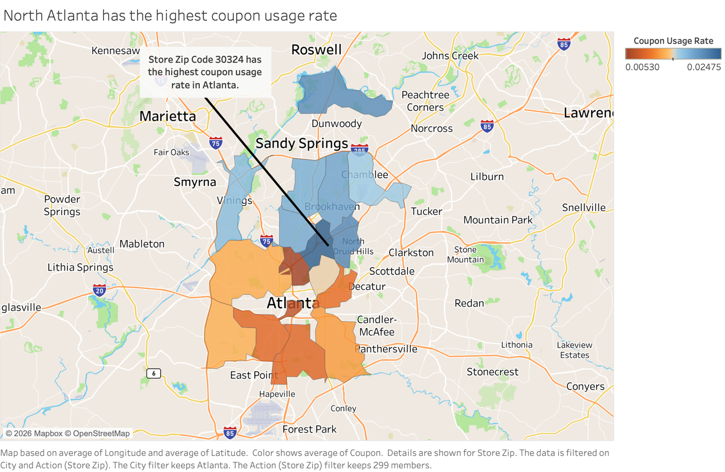

Directions given to students: Come up with an impactful, highly specific business question that Kroger might have, then use Tableau to answer it. Add a caption to tell us what the business question was, why the answer to this question would hold value to Kroger, and how/why this plot answers it.
- 5 pts – Plot passes the “6 second rule”. Can you tell what the student was getting at? Is the message clear? I think partial credit could be assigned based on “how close” you felt you were to understanding the story in those first few seconds.
Score and Comment:
- 5 pts – Compelling enough business question. Does their question/story yield some solid, actionable insight that Kroger could use to modify/improve some aspect of their business operations? If they did not add a caption describing the question and answer, the most they can get is 1 points here (and you’ll have to guess the question/adjust accordingly).
Score and Comment:
- 5 pts – “Follows best practices”: axes (if present) are labeled with useful values, # digits is appropriate, correct plot type for the type of data plotted, no dual axes (if looking at two quantities over time). These last 2 will almost always be free points since most students didn’t make those type of plots.
Score and Comment:
- 5 pts – Plot tells the intended story. Even if the plot is ugly/confusing, if it does answer their question that’s ok here. You might have to “guess” the story if they did not add a caption.
Score and Comment:

< insert image of dashboard plot here, leave the rest of this page unchanged >
